

Subject Name: Source Code Management
Subject Code: CS181
Cluster: Alpha
Department: CSE



Submitted By: Submitted To:
YATIN DORA DR. SHIKHA

2110991591
G-21

Source Code Management (Task 1.2)

S.No | Task Title | Page No.
1. | Add collaborators on GitHub Repo | 3 - 6
2. | Fork and Commit | 7 - 10
3. | Merge and Resolve conflicts created due to own activity and collaborators activity. | 11 - 13
4. | Reset and Revert | 14 - 15

EXPERIMENT- 1

AIM : Add collaborators on GitHub Repository

- Create a New Repository.

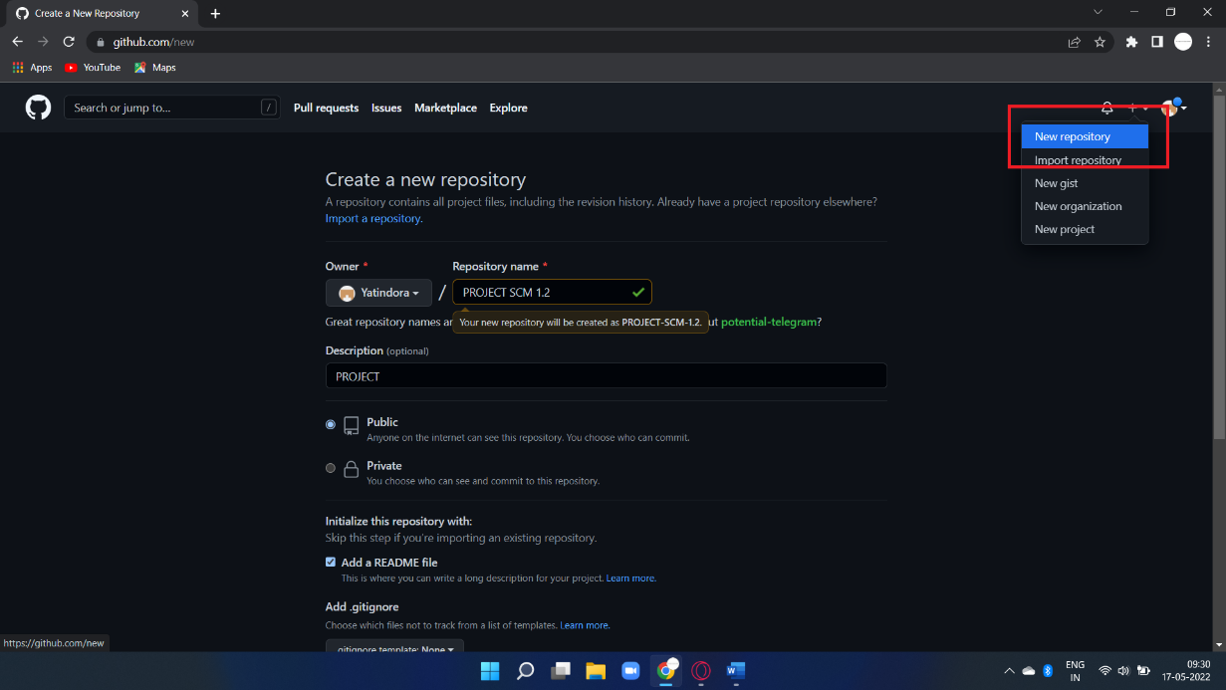

- Now Copy the HTTP link of your repo and paste it it on your ‘Git CLI’, and merge the local repo in remote repository.

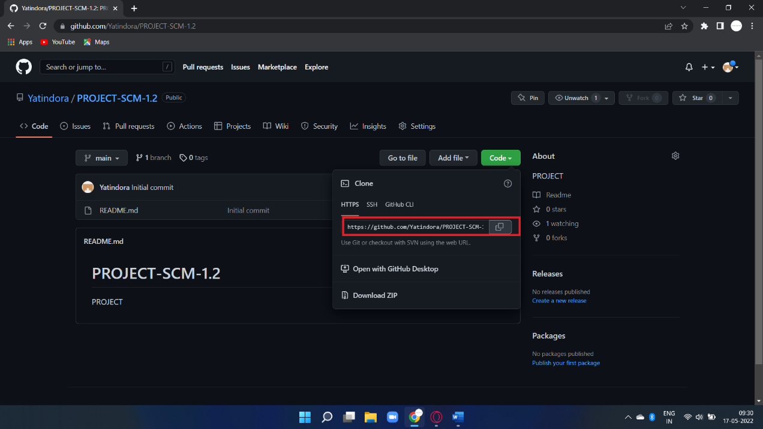

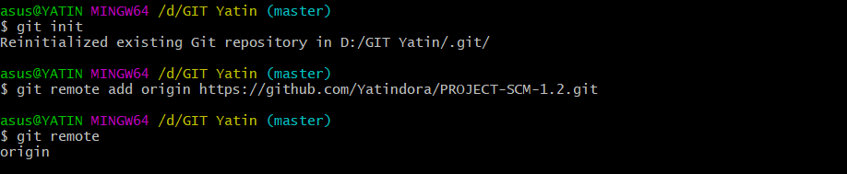

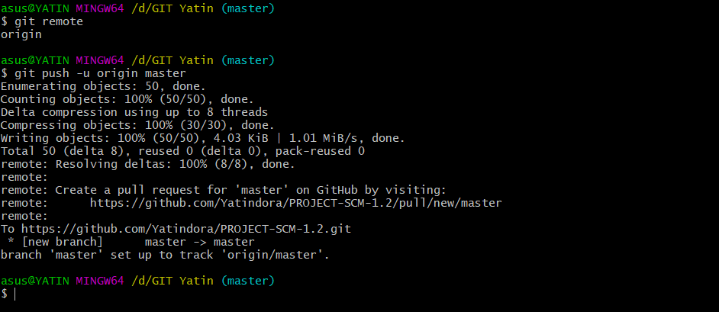

- Go to Collaborators in Repo Setting , Add the username or email of Collaborator you want to add in your Repo.

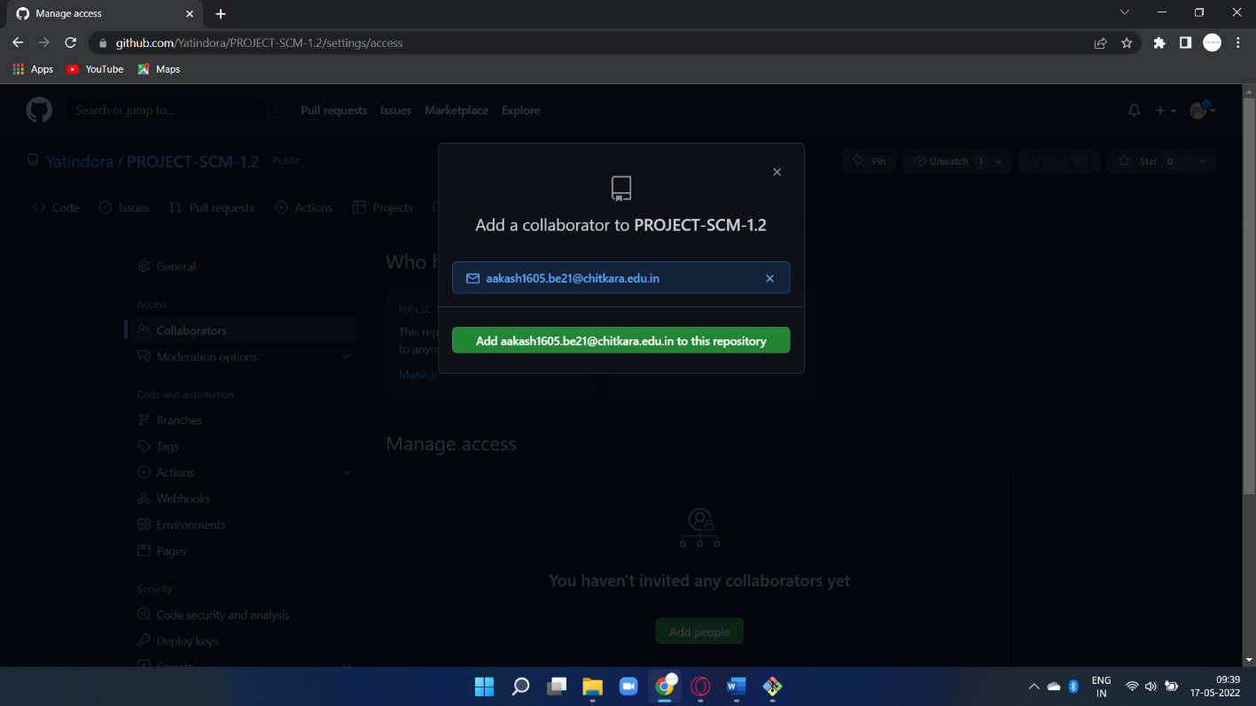

- Invitation Mail is sent to the Collaborator, The collaborator has to accept this Invitation.

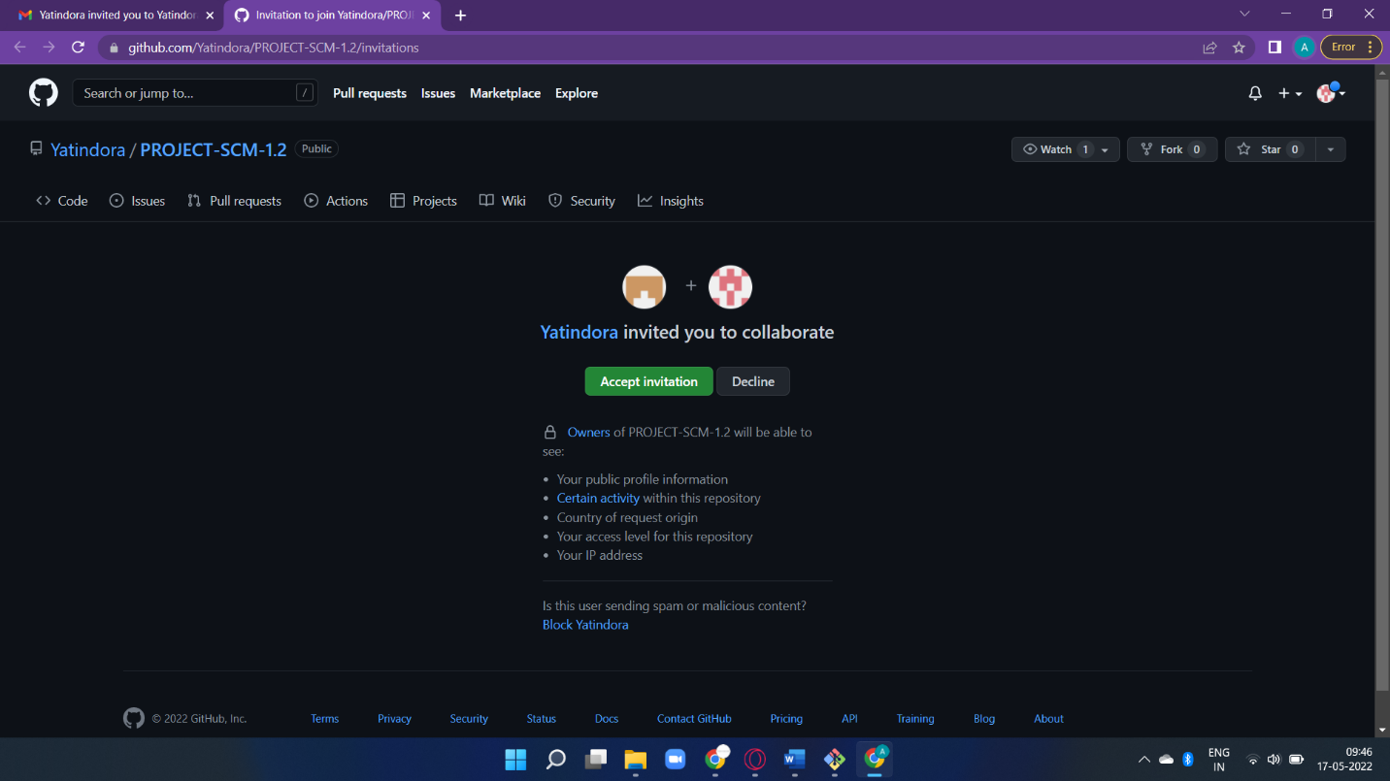

- New Collaborator has now access to the PROJECT SCM 1.2 .

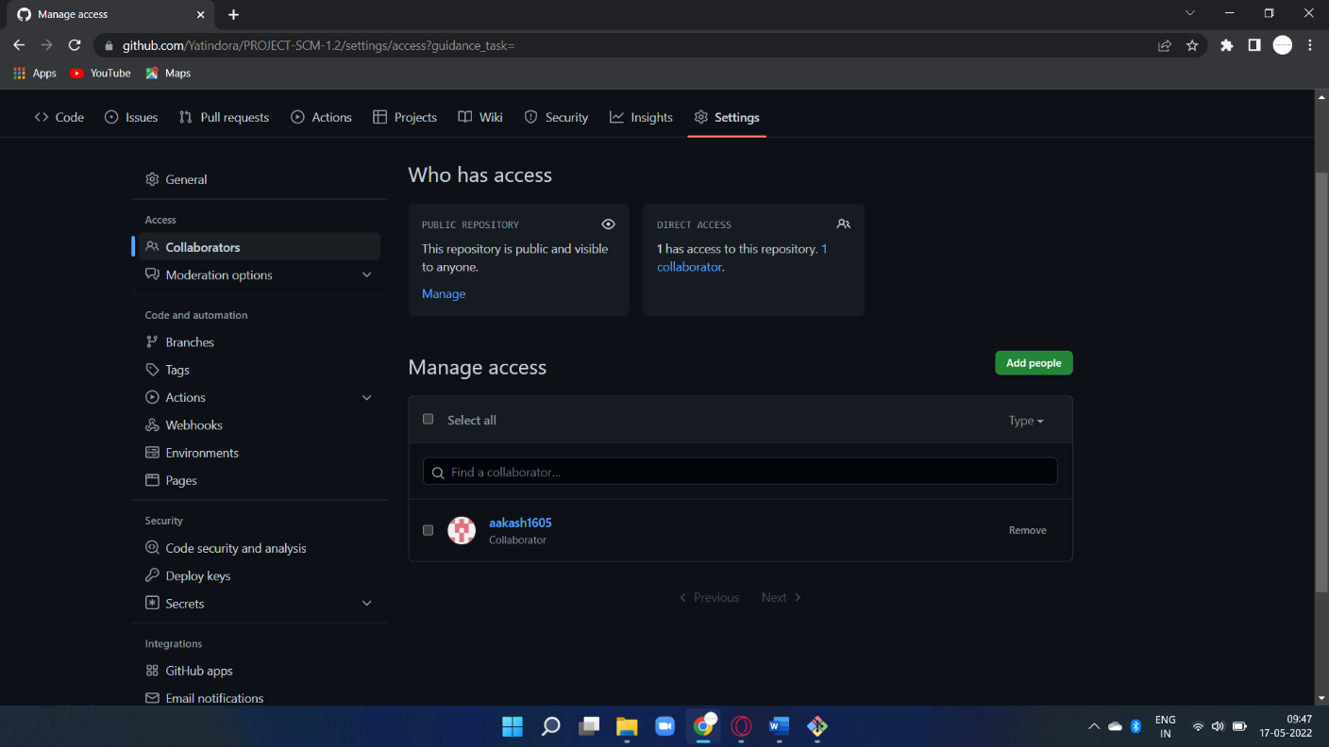

EXPERIMENT- 2
Task 2
Aim: FORK AND COMMIT

2.1 What is Forking a Repository mean and Why it is used?

Forking a repository means creating a copy of the repo. When you fork a repo, you create your own copy of the repository on your GitHub account. This is done for the following reasons:
- You have your own copy of the project on which you may test your own changes without changing the original project.
- This helps the maintainer of the project to better check the changes you made to the project and has the power to either accept, reject or suggest something.
- When you clone an Open Source project, which isn't yours, you don't have the right to push code directly into the project.

For these reasons, you are always suggested to FORK. Let's have a screenshot walkthrough of the whole process. When getting started with a contribution to Open Source Project, you have been advised to first FORK the repository(repo). But what is a fork?
You must have seen this icon on every repository in the top right corner. Now, this button is used to Fork the repo. But again, what is a fork or forking a repository in GitHub as shown in the below media as follows:
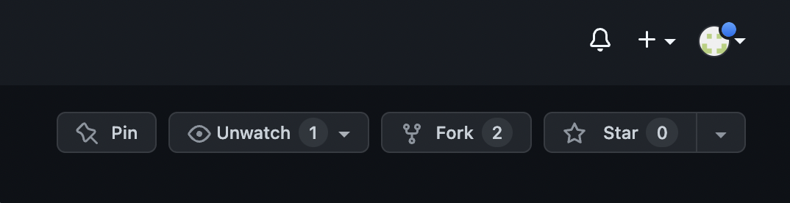

2.1.1 Procedure:
Step 1: Go to Projectwork official repository.
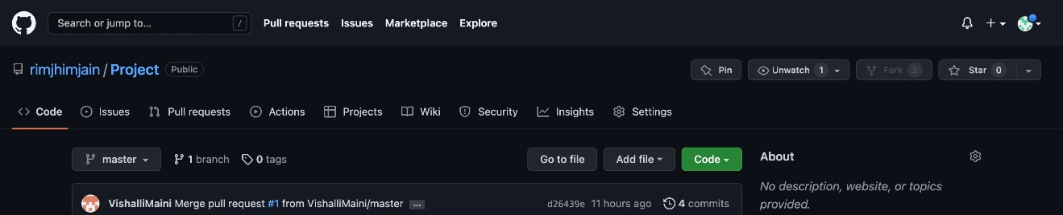

You can see rimjhimjain/projectwork This means rimjhimjain is the maintainer and Projectwork is the project's name.

Step 2: Find the Fork button on the top right corner.
You will see this screen.
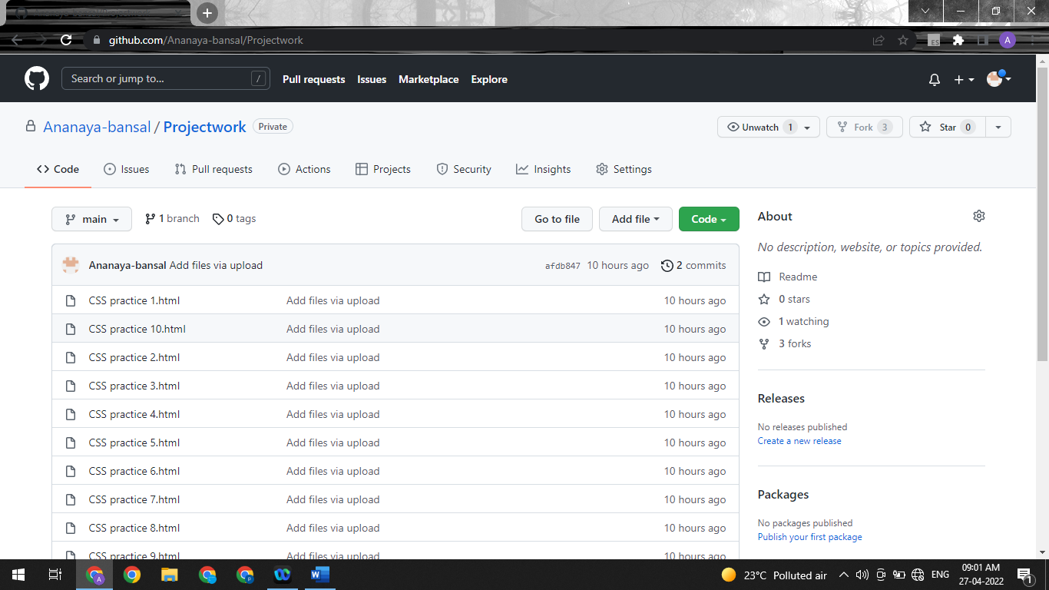
Step 3: Click on Fork.
Step 4: Now you have your own copy of the repository.
But how can we confirm for which do refer to below visual aid as follows:
Now we can see the prachisingla12/projectwork also below that, we have the link to the original project I forked from.
Whatever changes are made to ' prachisingla12/Projectwork ' will now change the original rimjhimjain/ProjectWork. We can make my changes here and then make a Pull Request to the maintainers of the project. Now it is in their hand if they will accept or reject your changes to the main project.
After this, we will see how to work in the forked repositories which were forked by the collaborators. If the collaborator tries to change in his forked repository, it will not affect the main repository.

2.2 What is COMMIT in GitHub?

Commit is like a snapshot of your repository. These commits are snapshots of your entire repository at specific times. You should make new commits often, based around logical units of change.
Over time, commits should tell a story of the history of your repository and how it came to be the way that it currently is.
Commits include lots of metadata in addition to the contents and message, like the author, timestamp and more.

It is similar to saving a file that’s been edited, a commit records changes to one or more files in your branch. Git assigns each commit a unique ID, called a SHA or hash, that identifies:

- The Specific Changes

- When the Changes were made
- Who created the changes

When you make a commit, you must include a commit message that briefly describes the changes, you can also add a co-author on any commits you collaborate on.

Now, we will see the main repository content of the main Projectwork Repository. We can see that there is a README.md file and other code files



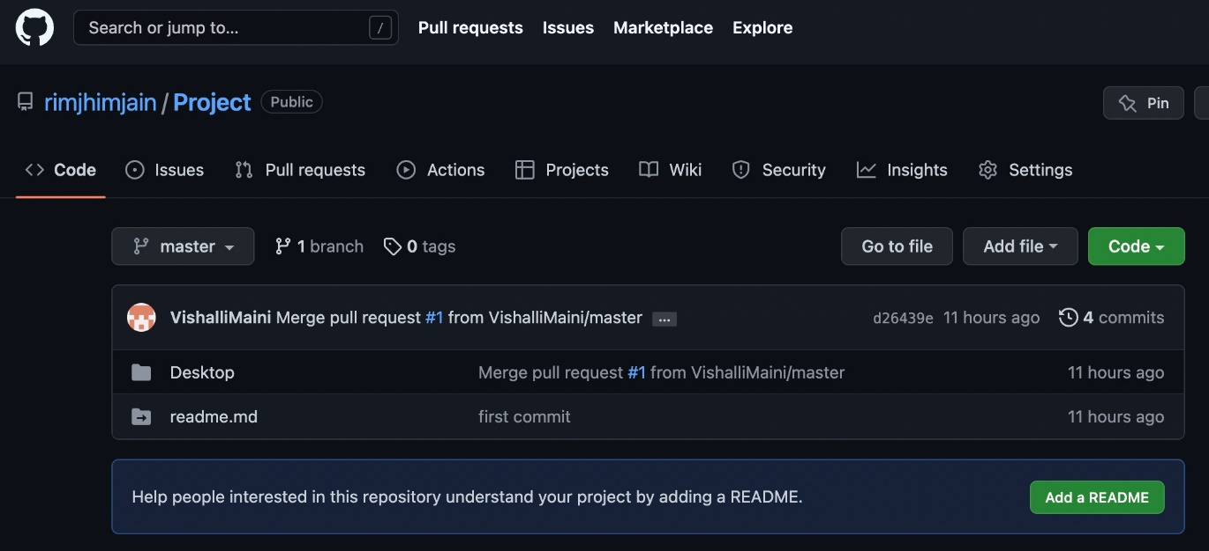

The content in the Desktop file in the main Projectwork repository, is given as below:
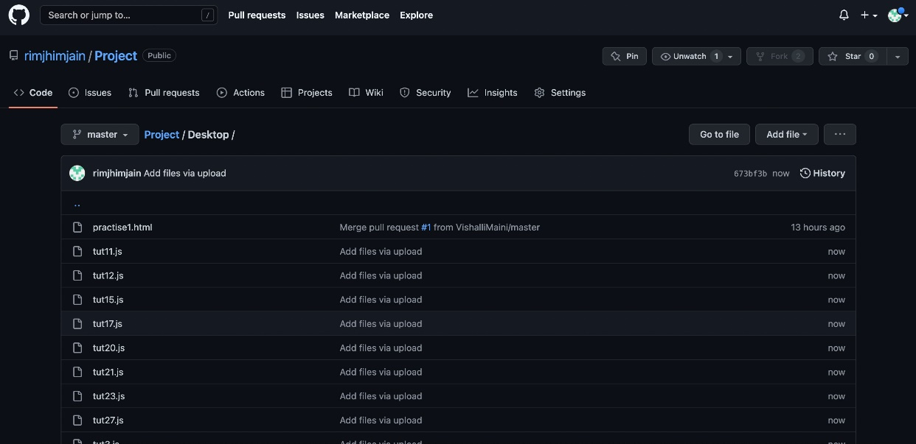

Now, we will see the prachisingla12/Projectwork repository. We know that this repository was forked from rimjhimjain/Projectwork , so the content of this repository should have same files, and we can see that it also has the README.md file with other code files and after opening it has the same content as that of the main repository file.

- Now, when collaborator tries to change the content of any of the file in his forked repository i.e.,

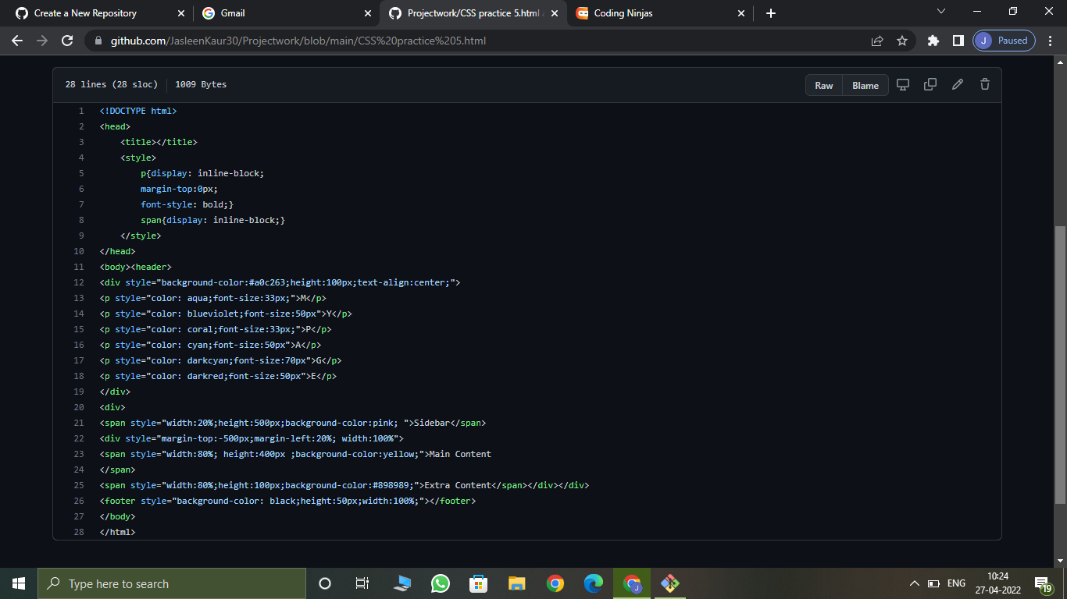
- We can see that the file has been edited and now it will be committed in this forked repository.

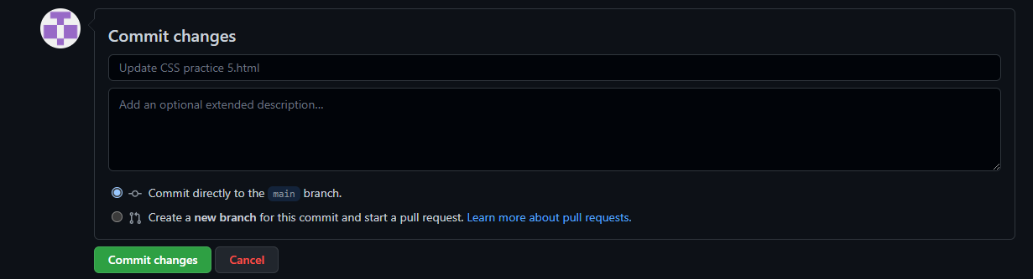

- We can see the Commit history of the Repository (Forked Repository).
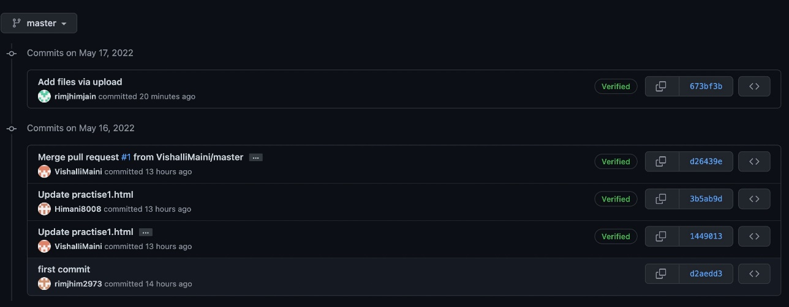

EXPERIMENT- 3

AIM: Merge and Resolve conflicts created due to own activity and collaborators activity.

- Do changes in master branch and commit those change. And checkout to “Feature- 1” branch and again do changes and commit it. Now checkout to master branch and merge the Feature-1 branch in master.
Commit in Master Branch
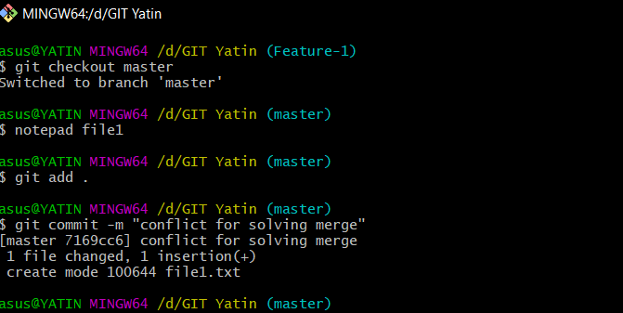

Commit in Feature-1 Branch

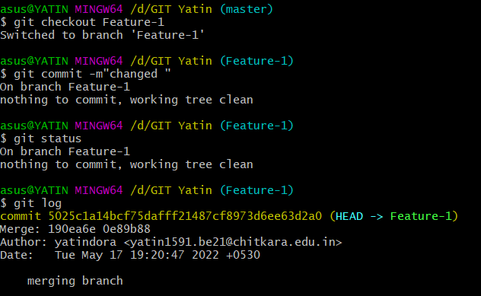

Due To My Activities , faces conflict during Merging

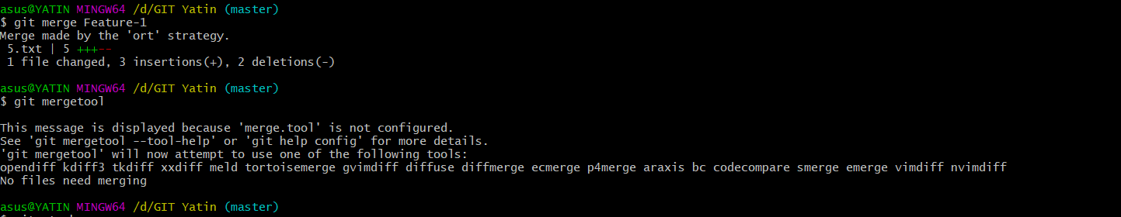

- Use Command “Git mergetool” to solve the conflict

git-mergetool - Run merge conflict resolution tools to resolve merge conflicts

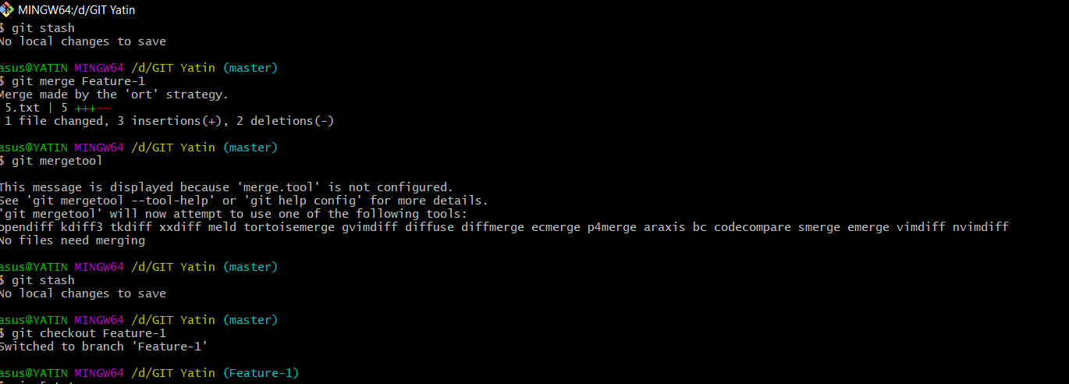

2. Press “I” to insert, after insertion. Press “:wq”. The merge conflict is solved and our Feature-1 branch is merged to master branch.

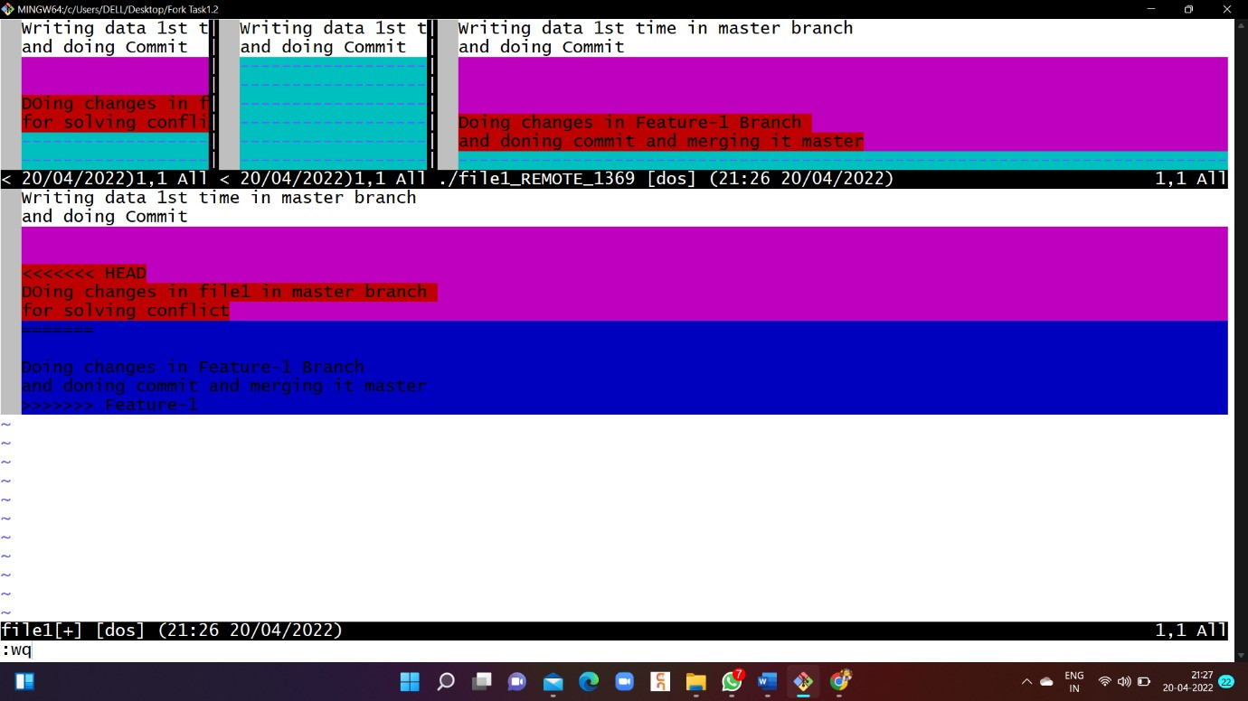

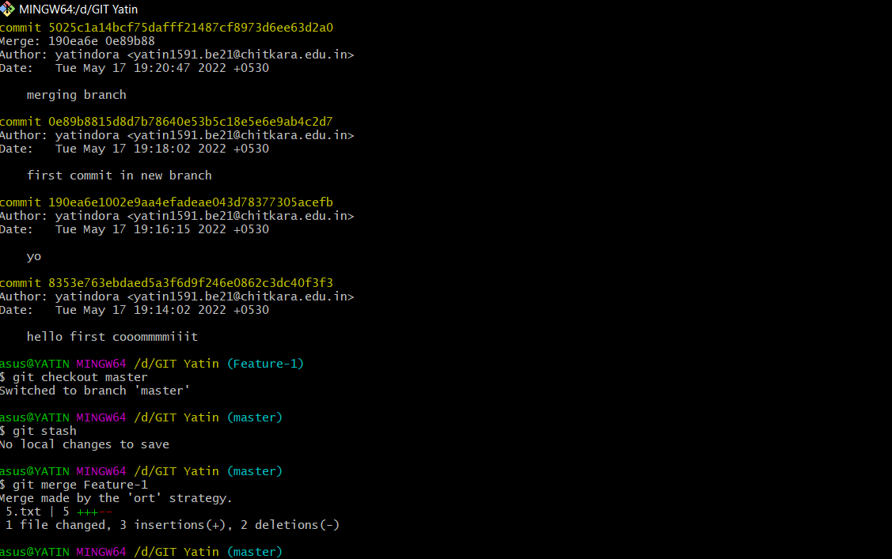

EXPERIMENT- 4

AIM : Reset and Revert

git-revert - Revert some existing commits.

- On GitBash CLI , Type command “git Commad <Commit id>” . It revert the changes that done before Commit.

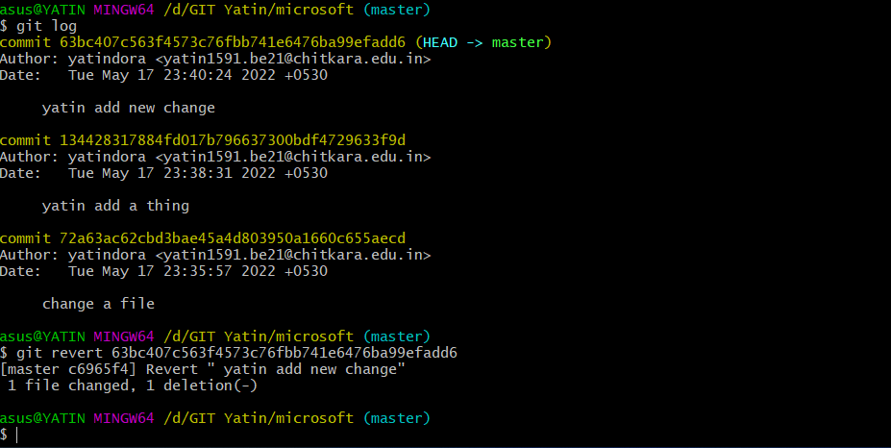

git revert HEAD~3 :-
Revert the changes specified by the fourth last commit in HEAD and create a new commit with the reverted changes.

git-reset - Reset current HEAD to the specified state.
At a surface level, git reset is similar in behavior to git checkout. Where git checkout solely operates on the HEAD ref pointer, git



reset will move the HEAD ref pointer and the current branch ref pointer. To better demonstrate this behavior consider the following example:

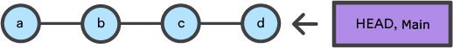

This example demonstrates a sequence of commits on the main branch. The HEAD ref and main branch ref currently point to commit d. Now let us execute and compare, both git checkout b and git reset b.

Git Reset
reset is the command we use when we want to move the repository back to a previous commit, discarding any changes made after that commit.
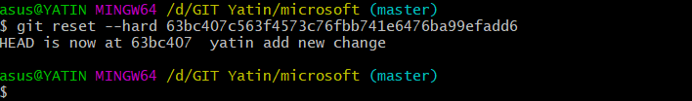

SUMMARY

The tasks performed in all are listed below:
  - Add collaborators on GitHub Repo

Fork and Commit
  - Merge and Resolve conflicts created due to own activity and collaborators activity.

Reset and Revert

